Module 7: Using Data to Improve Ecological Forecasts - Student Handout



### Name: Piper Zimmerman

### Student ID: poz3615

#### Completed on:

#### Copy-paste your save progress link from the Shiny app here for ease of reference: <https://macrosystemseddie.shinyapps.io/module7_dev/?_inputs_&plot_chla=1&plot_lag1=1&plot_lag2=1&calc_ac=1&plot_ac=1&plot_pacf=1&fit_model=1&calc_bias=1&calc_rmse=1&calc_proc_distrib=1&plot_high_freq=1&calc_ic_uc=1&fc1=1&fc1_viz=1&view_new_obs=1&update_ic=1&second_forecast_da=1&view_ic_no_da=2&second_forecast_no_da=1&plot_low_ic=1&plot_fc_low_obs_uc=1&plot_high_ic=1&plot_fc_high_obs_uc=1&fc_series_no_da=1&calc_bias2=1&calc_rmse2=1&fc_series_weekly=1&calc_bias3=1&calc_rmse3=1&fc_series_daily=1&calc_bias4=1&calc_rmse4=1&fc_scenario_weekly=1&fc_scenario_daily=1&fc_compare=1&calc_bias5=1&calc_rmse5=1&calc_bias6=1&calc_rmse6=1&show_ic=true&show_obs=true&show_obs2=true&show_obs3=true&_values_&sel_row=5>

# Macrosystems EDDIE Module 7: Using Data to Improve Ecological Forecasts

# Learning Objectives:

By the end of this module, you will be able to:

* Define data assimilation (Activity A)
* Generate an ecological forecast for primary productivity (Activity A)
* Describe how to assess ecological forecast accuracy (Activity A)
* Describe how data assimilation affects forecast accuracy and uncertainty (Activity B)
* Explain how updating models with data collected at different time scales (e.g., daily, weekly) and with different levels of associated uncertainty affects ecological forecasts (Activity B, C)

# Why macrosystems ecology and ecological forecasting?

**Macrosystems ecology** is the study of ecological dynamics at multiple interacting spatial and temporal scales (e.g., Heffernan et al. 2014). For example, *global* climate change can interact with *local* land-use activities to control how an ecosystem changes over the next decades. Macrosystems ecology recently emerged as a new sub-discipline of ecology to study ecosystems and ecological communities around the globe that are changing at an unprecedented rate because of human activities (IPCC 2013). The responses of ecosystems and communities are complex, non-linear, and driven by feedbacks across local, regional, and global scales (Heffernan et al. 2014). These characteristics necessitate novel approaches for making predictions about how systems may change to improve both our understanding of ecological phenomena as well as inform resource management.

**Forecasting** is a tool that can be used for understanding and predicting macrosystems dynamics. To anticipate and prepare for increased variability in populations, communities, and ecosystems, there is a pressing need to know the future state of ecological systems across space and time (Dietze et al. 2018). Ecological forecasting is an emerging approach which provides an estimate of the future state of an ecological system with uncertainty, allowing society to prepare for changes in important ecosystem services. Ecological forecasts are a powerful test of the scientific method because ecologists make a hypothesis of how an ecological system works; embed their hypothesis in a model; use the model to make a forecast of future conditions; and then when observations become available, assess the accuracy of their forecast, which indicates if their hypothesis is supported or needs to be updated. Forecasts that are effectively communicated to the public and managers will be most useful for aiding decision-making. Consequently, macrosystems ecologists are increasingly using ecological forecasts to predict how ecosystems are changing over space and time (Dietze and Lynch 2019).

In this module, students will generate an ecological forecast for a NEON site and explore how to use ecological data to improve forecast accuracy. This module will introduce students to the concept of data assimilation within an ecological forecast; how data assimilation can be used to improve forecast accuracy; how the level of uncertainty and temporal frequency of observations affects forecast output; and how data assimilation can affect decision-making using ecological forecasts.

## Module overview:

* Introductory presentation to the concepts of ecological forecasting, forecast accuracy and uncertainty, and data assimilation
* Activity A: Access and explore data from an ecological site of your choice in the National Ecological Observatory Network, then fit a model and generate a forecast of lake chlorophyll-a
* Activity B: Explore how updating model predictions with data affects forecast accuracy, including the effects of data observation uncertainty and temporal frequency
* Activity C: Update forecasts with data that have different levels of observation uncertainty for making management decisions

## Today’s focal question: *How can we use data to improve ecological forecasts?*

To be useful for management, ecological forecasts need to be both accurate enough for managers to be able to rely on them for decision-making and include a representation of forecast uncertainty, so managers can properly interpret the probability of future events. To improve forecast accuracy, we can update forecasts with observational data once they become available, a process known as data assimilation. Recent improvements in environmental sensor technology and an increase in the number of sensors deployed in ecosystems have increased the availability of data for assimilation to develop and improve forecasts for natural resource management.

In this module, you will explore how assimilating data with different amounts of observation uncertainty and at different temporal frequencies affects forecasts of lake water quality at an ecological site of your choice.

## R Shiny App:

The lesson content is hosted on an R Shiny App at <https://macrosystemseddie.shinyapps.io/module7/>

This can be accessed via any internet browser and allows you to navigate through the lesson via this app. You will fill in the questions below on this handout as you complete the lesson activities.

## Optional pre-class readings and video:

Webpages:

* [NOAA Ecological Forecasts](https://oceanservice.noaa.gov/ecoforecasting/noaa.html#:~:text=What%20is%20ecological%20forecasting%3F,%2C%20pollution%2C%20or%20habitat%20change.)
* [Ecological Forecasting Initiative](https://ecoforecast.org/about/)

Articles:

* Silver, N. (2012) Chapter 6: How to drown in three feet of water.Pages 176-203 inThe Signal and the Noise: Why so many Predictions Fail – but some Don’t. Penguin Books.
* Dietze, M. and Lynch, H. 2019. Forecasting a bright future for ecology. *Frontiers in Ecology and the Environment*, *17*(1), 3. <https://doi.org/10.1002/fee.1994>
* Dietze, M.C., et al. 2018. Iterative near-term ecological forecasting: Needs, opportunities, and challenges. Proceedings of the National Academy of Sciences, 115(7), 1424–1432. <https://doi.org/10.1073/pnas.1710231115>

Videos:

* NEON's [Ecological Forecast: The Science of Predicting Ecosystems](https://www.youtube.com/watch?v=Lgi_e7N-C8E&t=196s&pbjreload=101)
* Fundamentals of Ecological Forecasting Series: [Why Forecast?](https://www.youtube.com/watch?v=kq0DTcotpA0&list=PLLWiknuNGd50Lc3rft4kFPc_oxAhiQ-6s&index=1)
* Fundamentals of Ecological Forecasting Series: [Forecast Analysis Cycle](https://www.youtube.com/watch?v=zBsqjmdLYfk&list=PLLWiknuNGd50Lc3rft4kFPc_oxAhiQ-6s&index=1)
* Fundamentals of Ecological Forecasting Series: [Ensemble Kalman Filter](https://www.youtube.com/watch?v=UeFsEOGz_cc&list=PLLWiknuNGd50Lc3rft4kFPc_oxAhiQ-6s&index=1)

## Pre-class activity: Explore how data assimilation can affect forecast accuracy

Read the following paper, which you can either access independently online or obtain from your instructor:

*Luo, Y., Ogle, K., Tucker, C., Fei, S., Gao, C., LaDeau, S., Clark, J.S. and Schimel, D.S. (2011), Ecological forecasting and data assimilation in a data-rich era. Ecological Applications, 21: 1429-1442.* [*https://doi.org/10.1890/09-1275.1*](https://doi.org/10.1890/09-1275.1)

#### Refer to the paper you read to answer the questions below.

1. Define ‘data assimilation’.

* **Answer:**

1. Summarize why, in the authors’ opinion, data assimilation is needed for ecological forecasting.

* **Answer:**

1. Name one limitation of data assimilation in ecological forecasting.

* **Answer:**

1. The authors argue that the current, data-rich era in ecology is the perfect time to implement data assimilation more often in ecological modeling and forecasting. Why is the data-rich era an especially promising time for data assimilation efforts?

* **Answer:**

1. Provide one question you have after reading the paper. This could be, for example, a point you found confusing and would like to clarify, or a follow-up question on the topic.

* **Answer:**

Now navigate to the [Shiny interface](https://macrosystemseddie.shinyapps.io/module7) to answer the rest of the questions.

The questions you must answer are written both in the Shiny interface as well as in this handout. As you go, you should fill out your answers in this document.

# Think about it!

Answer the following questions:

1. What is meant by the term ‘data assimilation’ in the context of ecological forecasting?

* **Answer: Updating models and forecasts based on new available data, such as updated algal bloom forecast model in a week when we have an extra week of data of how much is in the lake.**

1. How do you think the process of integrating the most recently observed data into models can improve forecasts?

* **Answer: In addition to giving us more data, which is always helpful, it can help us stay on track with new patterns. For example, if algal blooms suddenly began to increase dramatically, an old model might not capture this. If we use the new data of increasing blooms in our model, it will better be able to track this pattern.**

# Activity A - Build A Model and Generate A Forecast

Explore chlorophyll-a data at a NEON site of your choice, then fit a model to the data and generate a forecast with uncertainty.

## Objective 1: Select and view a NEON site

Select a NEON site from the table, then click on the “View latest photo” button to load the latest image from that site. Follow the link at the bottom of the ‘About Site’ section to find out more about the site.

1. Fill out information about your selected NEON site.
   1. Name of selected site: Little Rock Lake
   2. Four letter site identifier: LIRO
   3. Latitude: 45.998269
   4. Longitude: -89704767
   5. Lake area (km2): 0.16
   6. Elevation (m): 501

## Objective 2: Explore water temperature

Explore the chlorophyll-a data measured at the selected site. This is data that has been downloaded from the NEON Data Portal. While we are using chlorophyll-a data in this module, there are a wide range of variables collected at each NEON site.

1. Why might a forecast of lake chlorophyll-a concentration days to weeks into the future be a useful tool for water managers?

* **Answer: If there is too much chlorophyll-a, it indicates there will be a lot of phytoplankton. Too much phytoplankton can lead to algal blooms, which can release toxins dangerous to health. If the forecast has a large amount of chlorophyll-a, a water manager might be able to get ahead of the problem.**

1. Describe chlorophyll-a data at your lake.
   1. Download the timeseries plot of chlorophyll-a data and copy-paste it into your report.
   * *Please copy-paste your Q5a-plot.png image here.*
   * 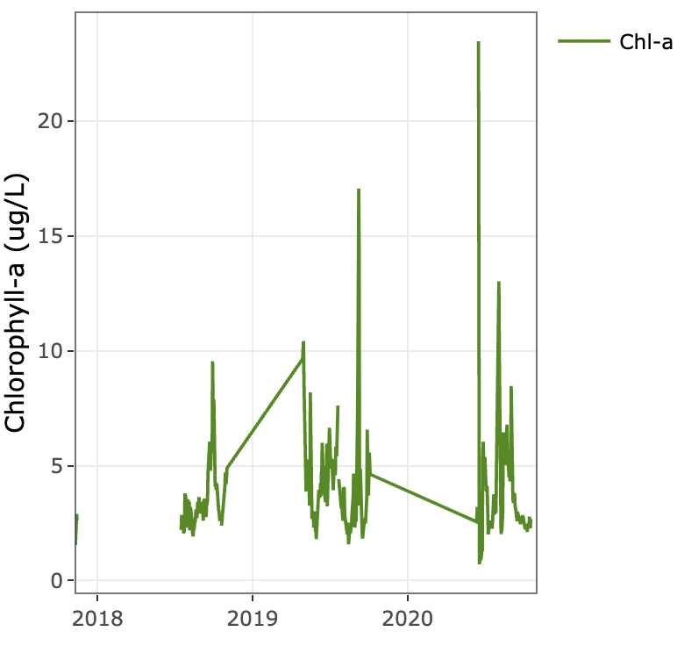
   * *Figure 1. Time series of chlorophyll-a data for your selected NEON lake.*
   1. Describe how chlorophyll-a changes over time in your lake. Do you notice any patterns or trends?
   * **Answer: There seems to be a general overall increase as time goes on. There also seems to be a little pattern throughout the year of decreasing and increasing concentrations.**

## Objective 3: Fit model

We will explore autocorrelation in the chlorophyll-a data at your selected NEON site and then fit an autoregressive model for forecasting.

1. Explain, in your own words, how autocorrelation in a variable can help forecasters make predictions of the future.

* **Answer: If a variable is very autocorrelated, we can expect the future values to be very similar to the past values.**

1. Describe what you observe on the timeseries plot of lagged chlorophyll-a. How do the two lines plotted on the timeseries (chlorophyll and 1 day lag of chlorophyll) relate to each other?
   1. Download the plot of lagged chlorophyll-a and copy-paste it into your report.
   * *Please copy-paste your Q7a-plot.png image here.*
   * 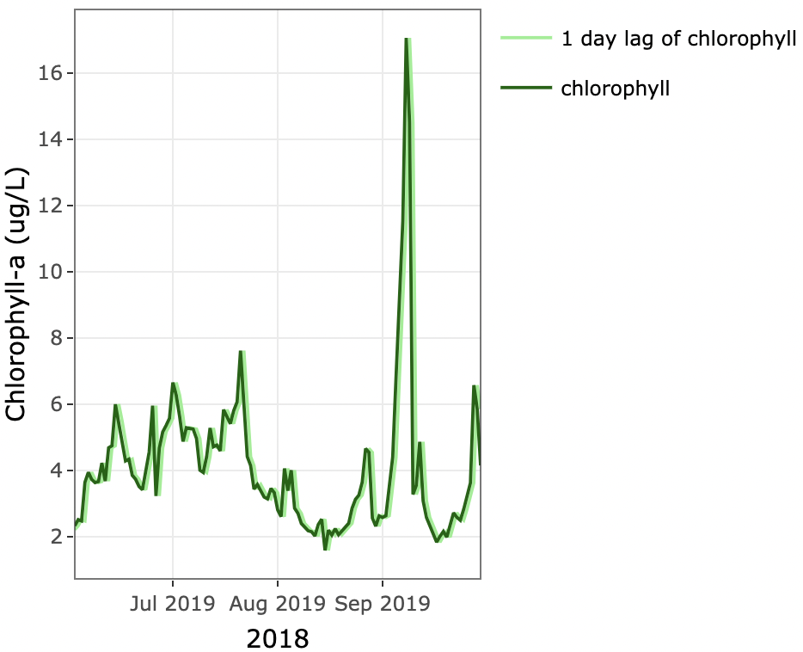
   * *Figure 2. Time series of lagged chlorophyll-a data for your selected NEON lake.*
   1. How do the two lines plotted on the timeseries (chlorophyll and 1 day lag of chlorophyll) relate to each other?
   * **Answer: The lines follow each other extremely closely, indicating that chlorophyll-a is autocorrelated.**
2. Describe what you observe on the scatterplot figure to the right. Do you think the chlorophyll-a data at your chosen lake site exhibit autocorrelation? Why or why not?
   1. Download the scatterplot and copy-paste it into your report.
   * *Please copy-paste your Q8a-plot.png image here.*
   * 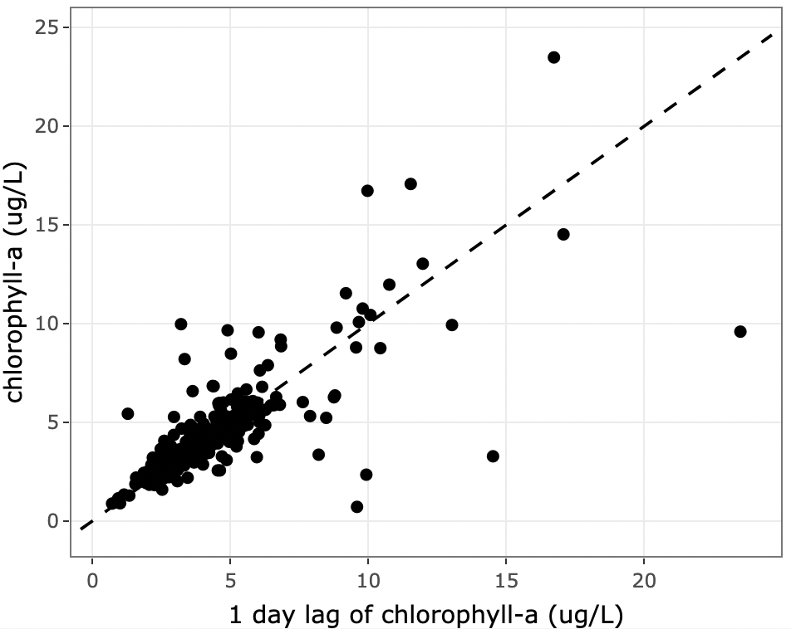
   * *Figure 3. Scatterplot of chlorophyll-a data vs. lagged chlorophyll-a data for your selected NEON lake.*
   1. Do you think the chlorophyll-a data at your chosen lake site exhibit autocorrelation? Why or why not?
   * **Answer: Based on the time series where the lines followed very closely, and this plot which closely follows the slope of 1 line, I do. The closer the values are, the closer they will follow that dotted line.**
3. Record the autocorrelation value you calculated. Does this value indicate low or high autocorrelation between chlorophyll-a and a 1-day lag of chlorophyll-a?

* **Answer: 0.792 indicated a high autocorrelation. 1 would be perfect autocorrelation, and our value is very high.**

1. Describe autocorrelation across many lags at your lake site.
   1. Download the autocorrelation plot and copy-paste it into your report.
   * *Please copy-paste your Q10a-plot.png image here.*
   * 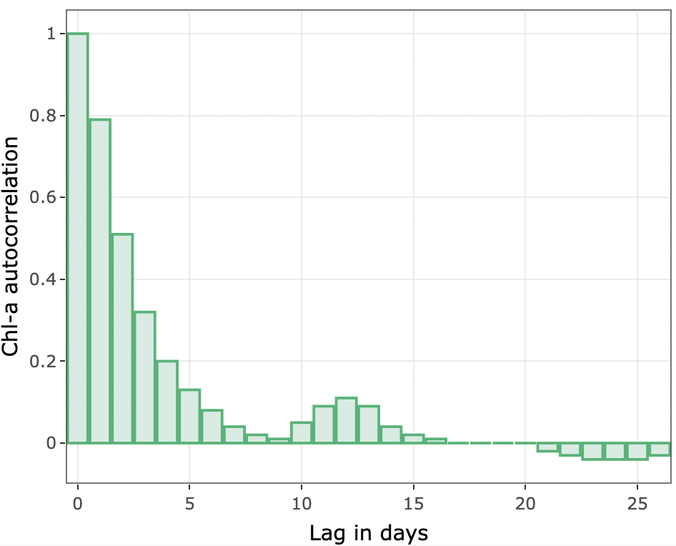
   * *Figure 4. Autocorrelation of lagged chlorophyll-a at your lake site.*
   1. Describe how autocorrelation changes as the lag in days increases. Why do you think this pattern occurs?
   * **Answer: As time goes on, the autocorrelation generally decreases. I think this occurs because of the growth. The value three weeks from today will not be as related as the value tomorrow.**
2. Imagine you are asked to develop a forecasting model that uses lagged values of chlorophyll-a to predict future chlorophyll-a. Examining the autocorrelation plot above, how many lags of chlorophyll-a would you include in your forecasting model? Provide your answer in days (e.g., I would include up to a 3-day lag) and explain your reasoning.

* **Answer: I would include up to a 4-day lag. The 4th day has an autocorrelation of 0.20, which could be helpful in the model. After the 4th day, the autocorrelation is very low and might not make any difference in the model.**

1. Examine the PACF plot.
   1. Download the PACF plot and copy-paste it into your report.
   * *Please copy-paste your Q12a-plot.png image here.*
   * 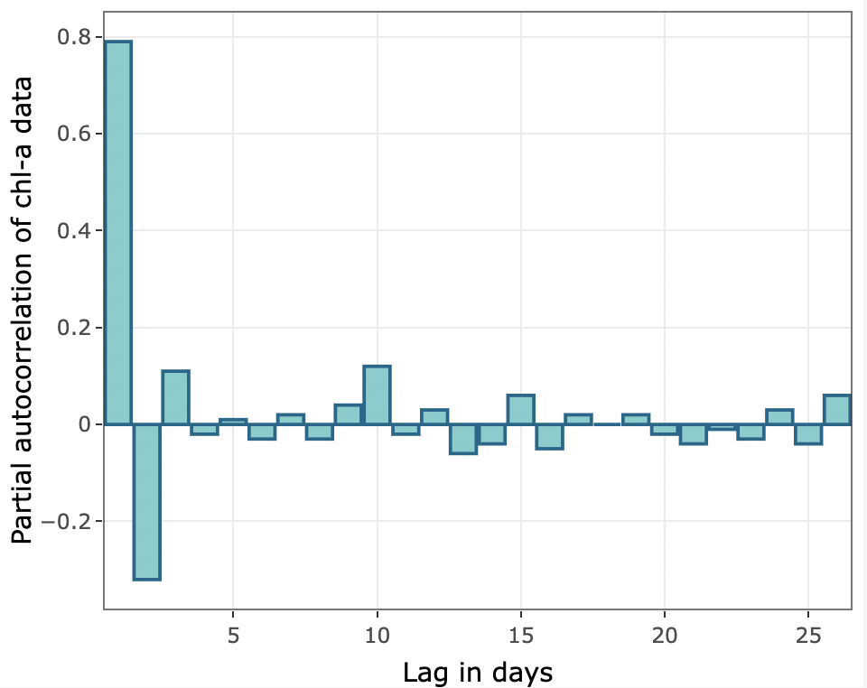
   * *Figure 5. Partial autocorrelation of chlorophyll-a at your lake site.*
   1. Examine the PACF plot. Which lag contributes the most to autocorrelation in the chlorophyll-a data? Explain how you know.
   * **Answer: The 1-day lag, it has the highest autocorrelation value.**
2. Once again, imagine you are asked to develop a forecasting model that uses lagged values of chlorophyll-a to predict future chlorophyll-a. Examining the PACF plot above, how many lags of chlorophyll-a would you include in your forecasting model? Provide your answer in days (e.g., I would include up to a 3-day lag) and explain your reasoning.

* **Answer: I would include a 2-day lag. Those are the only two that show an autocorrelation of magnitude greater than 0.2.**

1. Did the number of lags you chose to include in your forecasting model change from Q11 to Q13? Why or why not?

* **Answer: Yes. The number of lags in question 11 was including correlation with other lags, which was very high. The PACF just shows the lag’s autocorrelation.**

1. Use the plot above to assess the model fit to data.
   1. Download the plot of model predictions and observations and copy-paste it into your report.
   * *Please copy-paste your Q15a-plot.png image here.*
   * 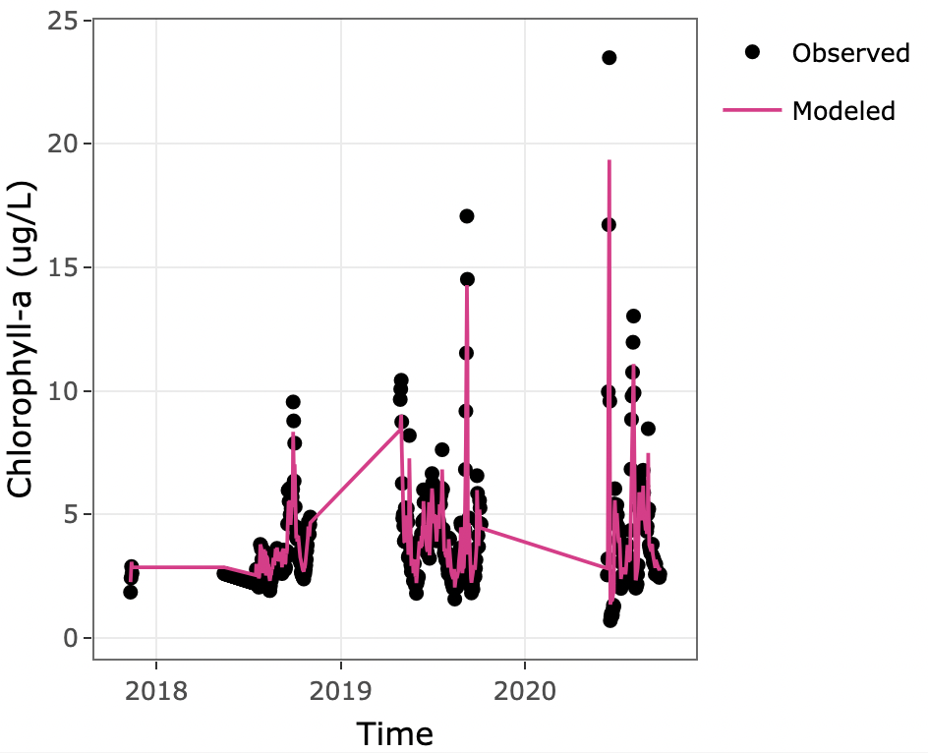
   * *Figure 6. Autoregressive model predictions and chlorophyll-a observations at your lake site.*
   1. How well do the predictions match the observations?
   * **Answer: It seems my predictions match the observations pretty well.**
2. Record your model bias. Then, use the calculated bias to assess the model fit to data. How good is the model fit? Explain your reasoning.

* **Answer: 0.0001- This indicates a very small bias in the model, suggesting it is a good fit.**

1. Record your model RMSE. Then, use the calculated RMSE to assess the model fit to data. How good is the model fit? Explain your reasoning.

* **Answer: 0.48- This is a small number, indicating that the predicted values aren’t very far from the observed values, and the model is a good fit.**

## Objective 4: Generate forecast

We will use the autoregressive model fit in the previous objective to generate a one-day-ahead forecast of chlorophyll-a with uncertainty for your chosen lake site.

1. Explain, in your own words, what forecast uncertainty is and why it is important to account for uncertainty in forecasts.

* **Answer: Forecast uncertainty happens because you do not know exactly what is going to happen. It is a range of values that you think is going to happen. It is important to account for uncertainty so that you can have a better idea of both how the model fits, and what the values are going to be.**

1. Record the value of your process uncertainty standard deviation in ug/L, and explain in your own words how this value was calculated.

* **Answer: 0.48 ug/L- This is calculated by taking the standard deviation of the model’s residuals, and generate a random normal distribution with the standard deviation of the residuals as the standard deviation.**

1. What data from your chosen lake are needed to provide the initial condition for your forecast model?

* **Answer: The concentration of chlorophyll-a today.**

1. Examine the plot of high-frequency chlorophyll-a data.
   1. Download the plot of high-frequency chlorophyll-a data and copy-paste it into your report.
   * *Please copy-paste your Q21a-plot.png image here.*
   * 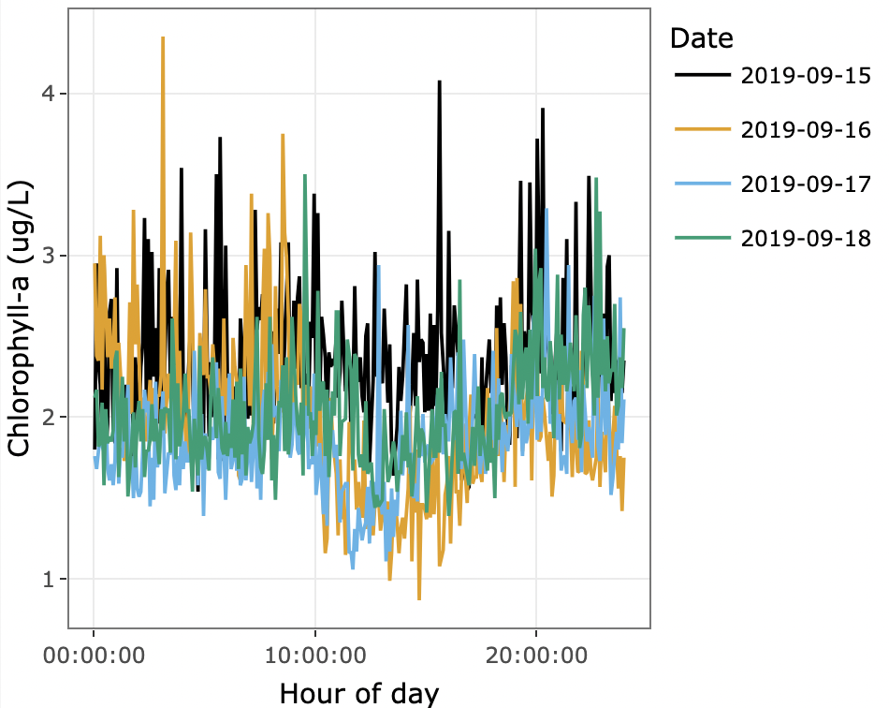
   * *Figure 7. High-frequency chlorophyll-a data at your lake site.*
   1. How variable is chlorophyll-a over the course of a day?
   * **Answer: It seems to be pretty variable. Some days the range is smaller, but on 2019-09-16, it ranges from less than 1ug/L, to more than 4ug/L.**
2. Record the value of your initial condition uncertainty standard deviation in ug/L, and explain in your own words how this value was calculated.

* **Answer: 0.4- This is calculated by taking the standard deviation of measurements for each day and averaging them. A distribution is then man with the current observation as the mean, and the standard deviation is the mean daily standard deviation.**

1. Examine the chlorophyll-a forecast plot.
   1. Download the chlorophyll-a forecast plot and copy-paste it into your report.
   * *Please copy-paste your Q23a-plot.png image here.*
   * 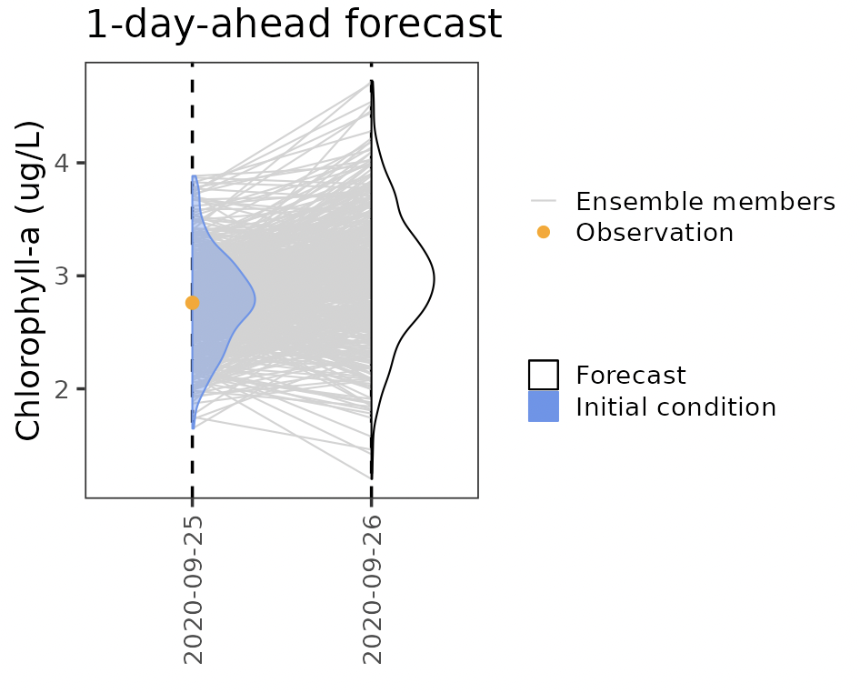
   * *Figure 8. A one-day-ahead forecast of chlorophyll-a at your lake site.*
   1. What is the forecasted chlorophyll-a concentration for Sept. 26, 2020?
   * **Answer: Between slightly less than 2ug/L and slightly larger than 4ug/L, but the most common forecast seems to be a little less than 3ug/L.**
   1. What is the relationship between the observed chlorophyll-a for Sept. 25, 2020, and the initial condition distribution (shown in blue)?
   * **Answer: The distribution has the most mass at the observed condition. That is the mean of the distribution.**
   1. Each one of the gray lines in the figure above represents an ensemble member. Explain what this means in your own words, with specific reference to the autoregressive model we are using for forecasting in this exercise.
   * **Answer: Each ensemble member from the initial condition distribution is making its own forecast for the 26th. They are all their own autoregressive model, but with different initial condition values, and different process noise values. Since it is very autocorrelated, the initial condition is very important in giving the forecast.**

# Activity B - Explore Data Assimilation

Now we will explore the effect of data assimilation on forecasts. First, we will compare forecasts generated with and without data assimilation. Then, we will investigate how the frequency of data assimilation (e.g., daily vs. weekly) and the amount of uncertainty associated with observations affects data assimilation and forecasts.

## Objective 5: Assimilate data

Compare one-day-ahead forecasts generated with and without data assimilation.

1. Briefly describe in your own words how an ensemble Kalman filter can be used to assimilate data into an ecological forecast.

* **Answer: An ensemble Kalman filter accounts for uncertainty in predictions and observations so that when updating the model with new data, information from both is included. It can also use this new data to update parameters using relationships in the model.**

1. Examine the forecast plot with an updated initial condition.
   1. Download the plot of a forecast with an updated initial condition and copy-paste it into your report.
   * *Please copy-paste your Q25a-plot.png image here.*
   * 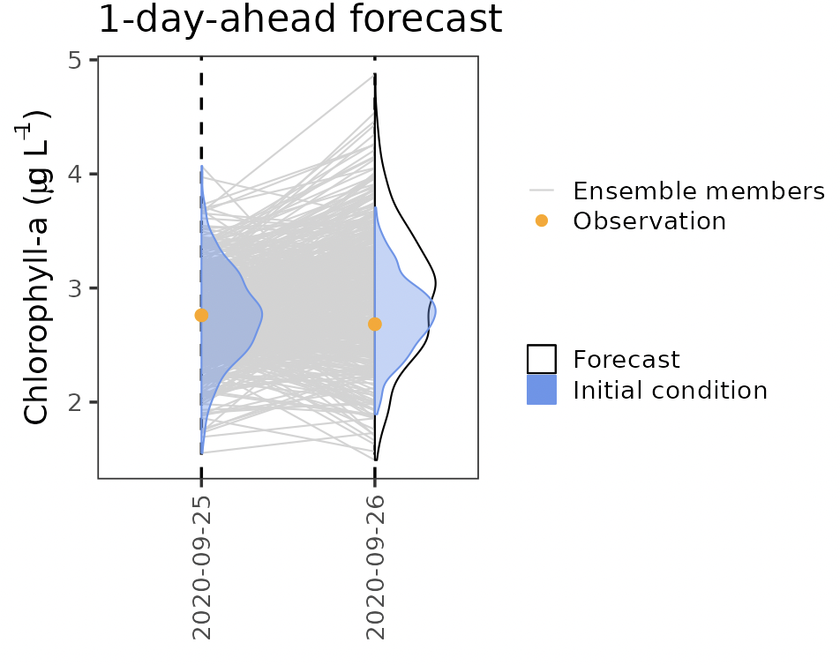
   * *Figure 9. One-day-ahead forecast with updated initial condition using newly observed chlorophyll-a data.*
   1. Compare the difference between the forecast distribution (white) for 2020-09-26 and the updated initial condition (blue distribution) for 2020-09-26. How are these two distributions different?
   * **Answer: The forecast distribution is much more spread out than the updated initial condition distribution.**
2. Examine the forecast plot with an updated initial condition when data are missing.
   1. Download the plot of the updated initial condition when data are missing and copy-paste it into your report.
   * *Please copy-paste your Q26a-plot.png image here.*
   * 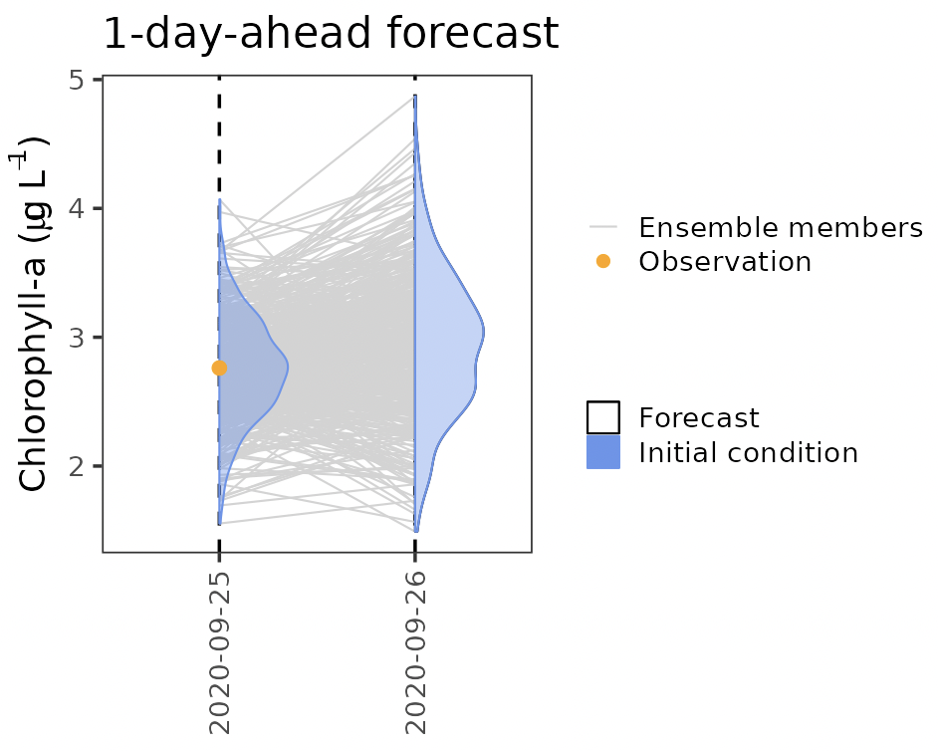
   * *Figure 10. One-day-ahead forecast with updated initial condition when chlorophyll-a data are missing.*
   1. Compare the forecast distribution (white) for 2020-09-26 and the updated initial condition (blue distribution) for 2020-09-26. What happened when there was no new observation to update the forecast?
   * **Answer: The forecast distribution and the updated initial condition distribution are the exact same when there was no new observation to update the forecast.**
3. Compare the two-forecast plot with no data assimilation (missing observation) to the two-forecast plot with data assimilation.
   1. Download the two-forecast plot with data assimilation and copy-paste it into your report.
   * *Please copy-paste your Q27a-plot.png image here.*
   * 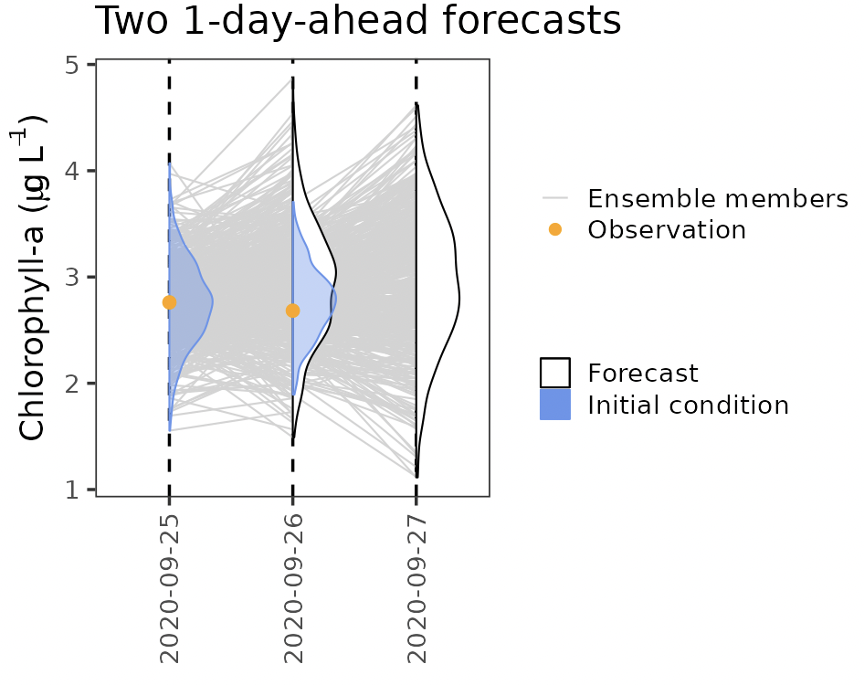
   * *Figure 11. Two-forecast plot with data assimilation.*
   1. Download the two-forecast plot with no data assimilation (missing observation) and copy-paste it into your report.
   * *Please copy-paste your Q27b-plot.png image here.*
   * 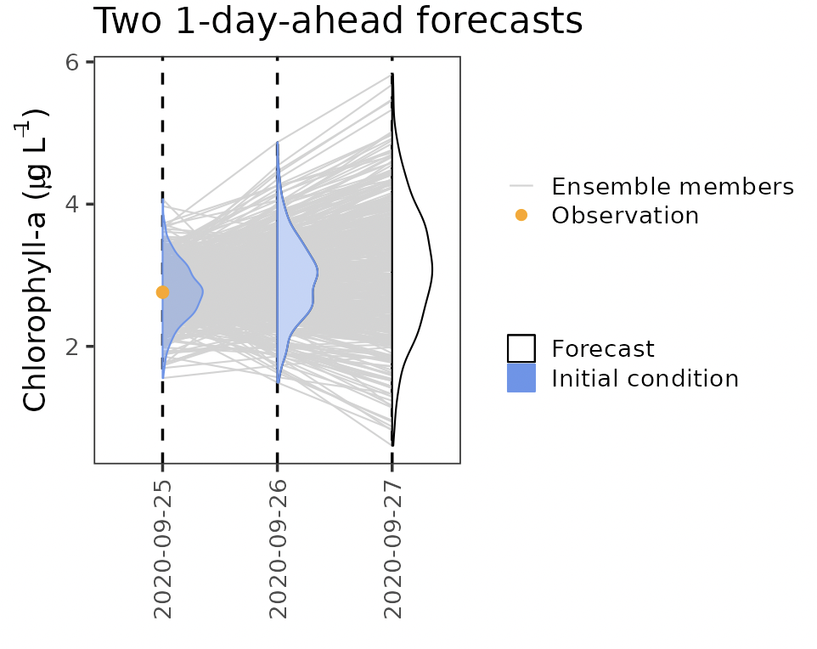
   * *Figure 12. Two-forecast plot without data assimilation.*
   1. How do the forecasts for 2020-09-27 on each plot compare?
   * **Answer: While the two forecasts are very similar shapes, if you look at the scale, you can see that the y-axis of the plot with data assimilation is 1-5, while the y-axis of the plot without data assimilation is 0-6, so the range is larger.**

## Objective 6: Explore observation uncertainty

Compare one-day-ahead forecasts generated with data assimilation, using data with low vs. high observation uncertainty.

1. Make a prediction. How do you think a decrease in observation uncertainty will affect the forecasts?

* **Answer: A decrease in observation uncertainty will cause a decrease in forecast uncertainty. If we are more sure about our observation, there will be less variability with it.**

1. Compare the initial conditions distributions (blue) in Figure A with those in Figure B.
   1. Download the plot of forecasts assimilating data with low observation uncertainty and copy-paste it into your report.
   * *Please copy-paste your Q29a-plot.png image here.*
   * 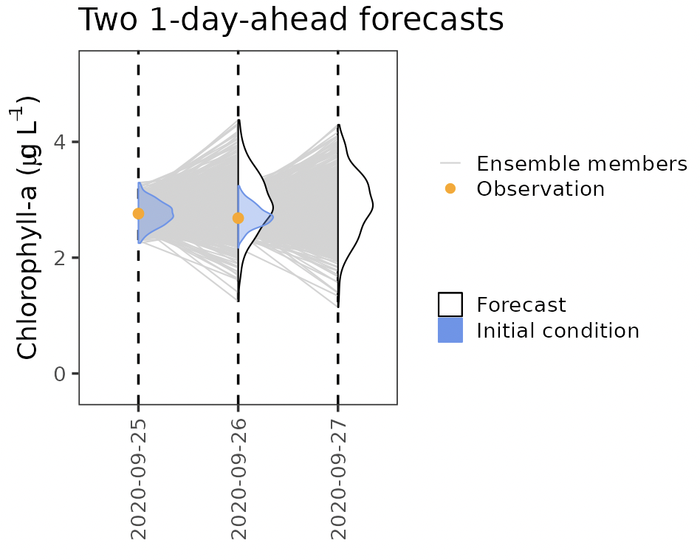
   * *Figure 13. Plot of forecasts assimilating data with low observation uncertainty.*
   1. Describe how the initial conditions distributions differ between the two figures.
   * **Answer: The initial condition distribution in our new plot (Figure 13) with lower observation uncertainty is much less spread out.**
   1. What is the effect of a decrease in observation uncertainty on the forecasts? Does this match what you predicted in Q28?
   * **Answer: A decrease in observation uncertainty cause a decrease in the spread of the distribution, which caused a decrease in forecast uncertainty. This is what I predicted previously.**
2. Make a prediction. Using your experience from the previous example, how do you think an increase in observation uncertainty will affect the forecasts?

* **Answer: I think an increase in observation uncertainty will cause more forecast uncertainty. The spread of the initial condition distribution will be much more spread out.**

1. Compare the initial conditions distributions (blue) in Figure C above with those in Figure D.
   1. Download the plot of forecasts assimilating data with high observation uncertainty and copy-paste it into your report.
   * *Please copy-paste your Q31a-plot.png image here.*
   * 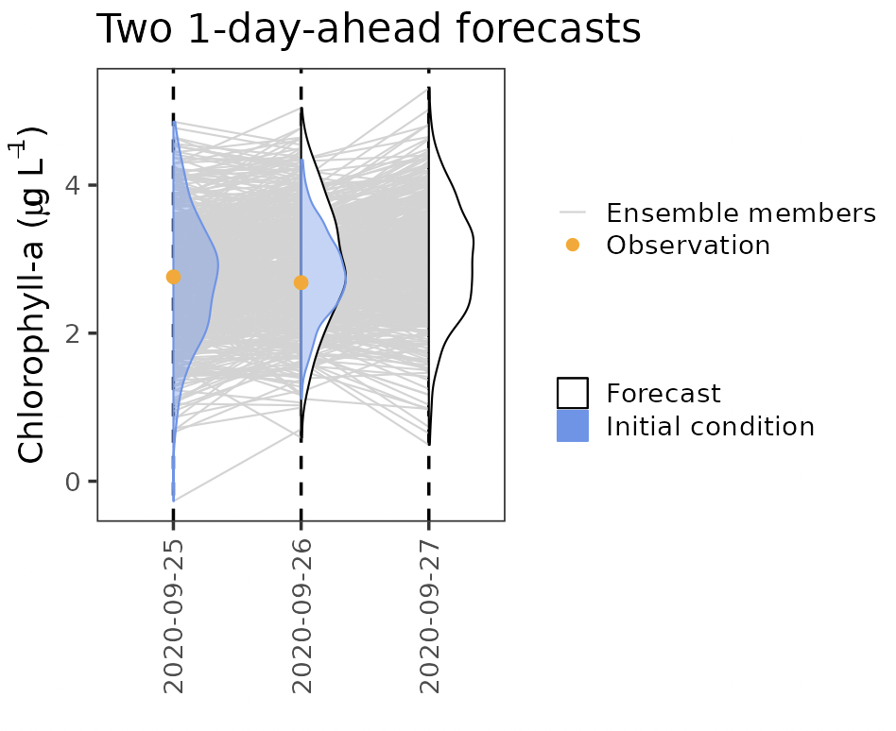
   * *Figure 14. Plot of forecasts assimilating data with high observation uncertainty.*
   1. Describe how the initial conditions distributions differ between the two figures.
   * **Answer: The initial condition distribution in Figure 14 is much more spread out than that in the previous figure.**
   1. What is the effect of an increase in observation uncertainty on the forecasts? Does this match what you predicted in Q30?
   * **Answer: An increase in observation uncertainty causes more forecast uncertainty. The distribution has a much larger spread. This matches what I predicted previously.**

## Objective 7: Explore data assimilation frequency

Compare a series of one-day-ahead forecasts with no data assimilation, weekly data assimilation, and daily data assimilation.

1. Make a prediction by filling in the blank: as the frequency of data assimilation increases, forecast accuracy ____________. Choose from ‘increases’, ‘decreases’, or ‘stays the same.’

* **Answer: Increases**

1. Describe the series of one-day-ahead forecasts with no data assimilation.
   1. Download the plot of a series of one-day-ahead forecasts with no data assimilation and copy-paste it into your report.
   * *Please copy-paste your Q33a-plot.png image here.*
   * 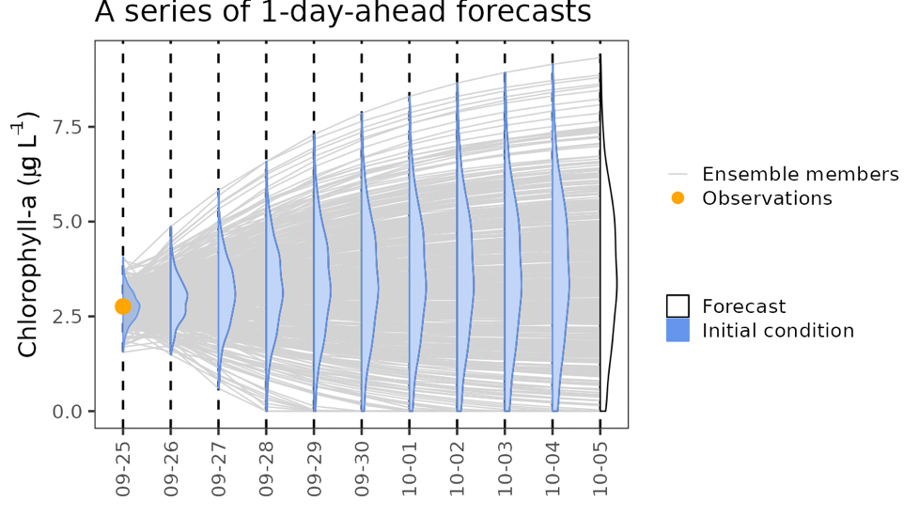
   * *Figure 15. A series of one-day-ahead forecasts with no data assimilation.*
   1. Describe how the mean value of the 1-day-ahead forecasts changes over time when no data are assimilated.
   * **Answer: It seems that the mean value of the 1-day ahead forecasts changes very minimally, or not at all.**
   1. Describe how the uncertainty distribution of the 1-day-ahead forecasts changes over time when no data are assimilated.
   * **Answer: The spread of the uncertainty distribution continues to get much large as we forecast further ahead.**
2. Assess the series of one-day-ahead forecasts with no data assimilation.
   1. Click the “show observations” checkbox under the plot above, and then visually assess the forecasts and describe their accuracy. How well do they match observations?
   * **Answer: The forecasts are all accurate. The observation is within the distribution, and generally close to the center of the distribution. However, the spread of the distribution, or the uncertainty, is very large.**
   1. Click the buttons to calculate bias and RMSE, and then use the values of bias and RMSE to assess the forecasts with no data assimilation. How well do you think the forecasts are performing?
   * **Answer: The bias is 0.8228 and the RMSE is 0.93. Both of these values are relatively high, indicating that the forecasts could be doing better.**
3. Describe the series of one-day-ahead forecasts with weekly data assimilation.
   1. Download the plot of a series of one-day-ahead forecasts with weekly data assimilation and copy-paste it into your report.
   * *Please copy-paste your Q35a-plot.png image here.*
   * 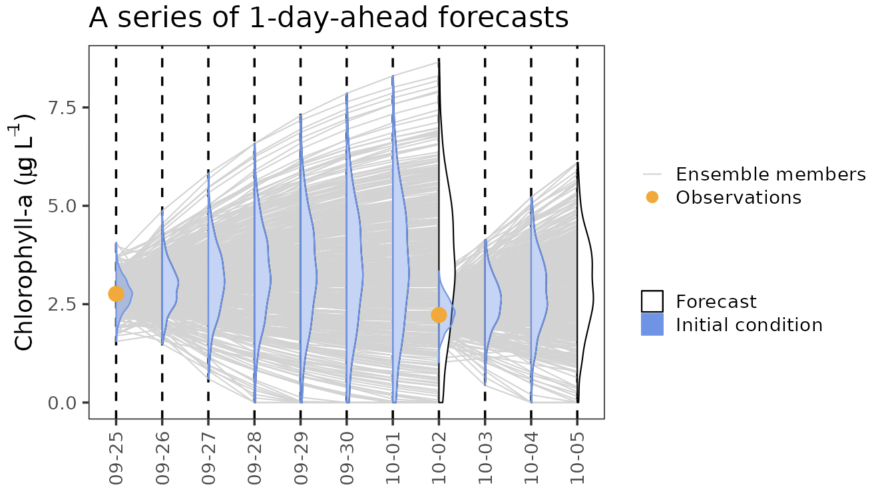
   * *Figure 16. A series of one-day-ahead forecasts with weekly data assimilation.*
   1. Describe how the mean value of the 1-day-ahead forecasts changes over time when weekly data are assimilated.
   * **Answer: Like before, the mean value doesn’t seem to be changing much. However, when we assimilate new data, the mean shifts towards that new point.**
   1. Describe how the uncertainty distribution of the 1-day-ahead forecasts changes over time when weekly data are assimilated.
   * **Answer: Like before, the uncertainty distribution increases in spread as we forecast further into the future. However, when we assimilate new data, the spread reduces greatly and begins the pattern again.**
4. Assess the series of one-day-ahead forecasts with weekly data assimilation.
   1. Click the “show observations” checkbox under the plot above, and then visually assess the forecasts and describe their accuracy. How well do they match observations?
   * **Answer: The observations are all in the forecast distributions like before, but now the spread is smaller, so our forecasts are more accurate.**
   1. Click the buttons to calculate bias and RMSE, and then use the values of bias and RMSE to assess the forecasts with weekly data assimilation. How well do you think the forecasts are performing?
   * **Answer: The bias is 0.5816 and the RMSE is 0.67. These numbers are smaller than the bias and RMSE from the forecasts without data assimilation, meaning that these forecasts are doing better.**
5. Describe the series of one-day-ahead forecasts with daily data assimilation.
   1. Download the plot of a series of one-day-ahead forecasts with daily data assimilation and copy-paste it into your report.
   * *Please copy-paste your Q37a-plot.png image here.*
   * 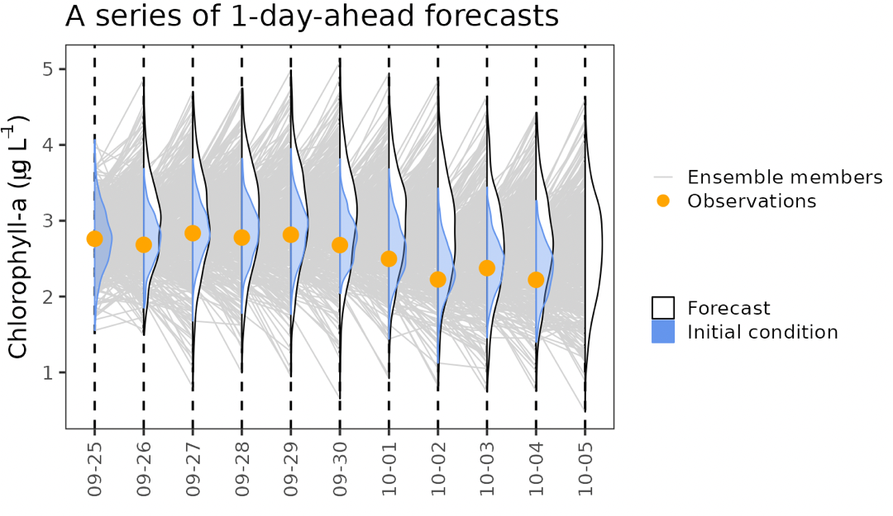
   * *Figure 17. A series of one-day-ahead forecasts with daily data assimilation.*
   1. Describe how the mean value of the 1-day-ahead forecasts changes over time when daily data are assimilated.
   * **Answer: The mean value changes a little bit with daily data assimilated.**
   1. Describe how the uncertainty distribution of the 1-day-ahead forecasts changes over time when daily data are assimilated.
   * **Answer: The uncertainty distribution of the 1-day-ahead forecasts gets more spread out as time goes on, but not nearly as quickly, and seems to shrink again after data assimilation.**
6. Assess the series of one-day-ahead forecasts with daily data assimilation.
   1. Click the “show observations” checkbox under the plot above, and then visually assess the forecasts and describe their accuracy. How well do they match observations?
   * **Answer: The observation is in the forecast distribution, and close to the middle, so that is a good sign. The observations match fairly well.**
   1. Click the buttons to calculate bias and RMSE, and then use the values of bias and RMSE to assess the forecasts with daily data assimilation. How well do you think the forecasts are performing?
   * **Answer: The bias is 0.3298 and the RMSE is 0.36. These are the smallest values yet, meaning these forecasts are performing the best.**
7. Fill in the blank: as the frequency of data assimilation increases, forecast accuracy ____________. Choose from ‘increases’, ‘decreases’, or ‘stays the same.’ How does your answer now compare to what your answer in Q32?

* **Answer: Increases. This is the same as I predicted previously.**

# Activity C - Management Scenario

Make management decisions using ecological forecasts generated with different levels of observation uncertainty and different frequencies of data assimilation.

## Objective 8: Management scenario

Make management decisions using ecological forecasts generated with different levels of observation uncertainty and different frequencies of data assimilation.

1. Make a preliminary recommendation. Based on what you have learned in Activities A and B, do you recommend that the Green Reservoir management authority invest in a new high-frequency sensor to inform their forecasts?

* **Answer: Yes, I would recommend a high-frequency sensor. With more data, we can get a better fit and better forecasts with our model.**

1. Make a management decision.
   1. Download the plot of the series of forecasts generated using the current forecasting system and copy-paste it into your report.
   * *Please copy-paste your Q41a-plot.png image here.*
   * 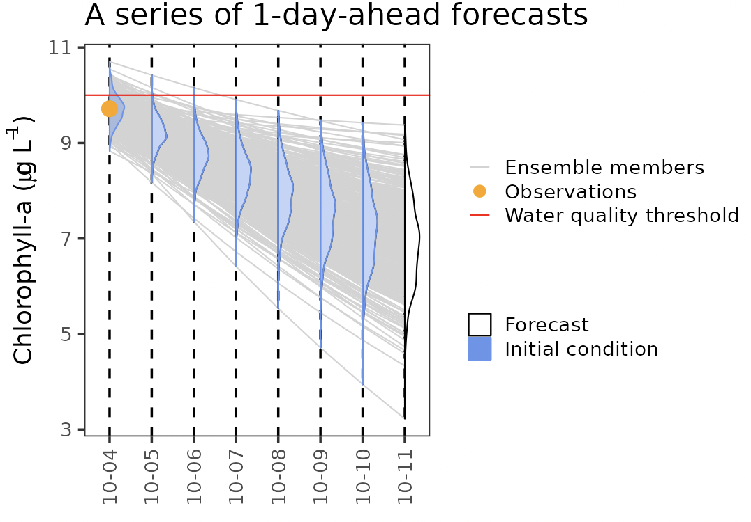
   * *Figure 18. A series of of one-day-ahead forecasts generated using the current forecasting system and data collection method.*
   1. Based on the forecasts presented here, as a manager, would you recommend a beach closure for Saturday, October 11?
   * **Answer: I would not recommend a beach closure for October 11. The distribution of our forecast is all below the water quality threshold, so it seems safe to keep the beach open.**
2. Make a management decision.
   1. Download the plot of the series of forecasts generated using the borrowed high-frequency sensor and copy-paste it into your report.
   * *Please copy-paste your Q42a-plot.png image here.*
   * 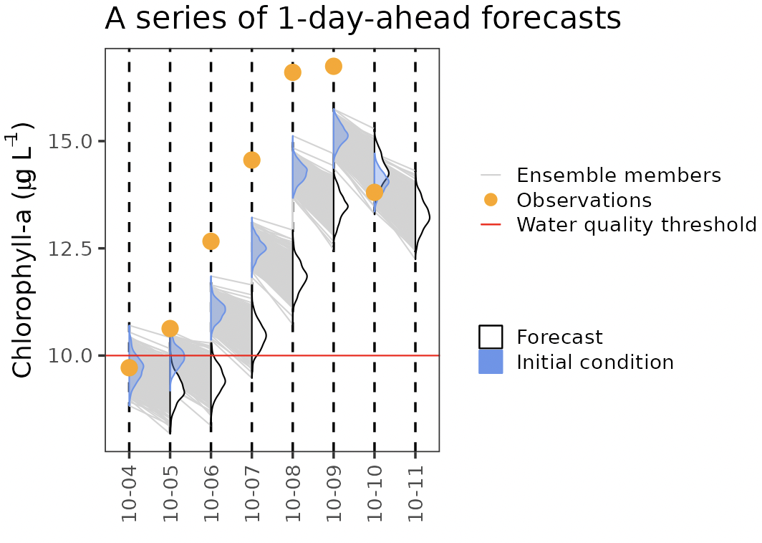
   * *Figure 19. A series of of one-day-ahead forecasts generated using the borrowed high-frequency sensor.*
   1. Based on the forecasts presented here, as a manager, would you recommend a beach closure for Saturday, October 11?
   * **Answer: I would definitely recommend a beach closure for October 11. The entire forecast distribution is way above the water quality threshold. It does not seem safe to keep the beach open.**
3. Compare the two series of forecasts.
   1. Download the plot of the series of forecasts generated using the current forecasting system AND the observation for Saturday, Oct. 11 and copy-paste it into your report.
   * *Please copy-paste your Q43a-plot.png image here.*
   * 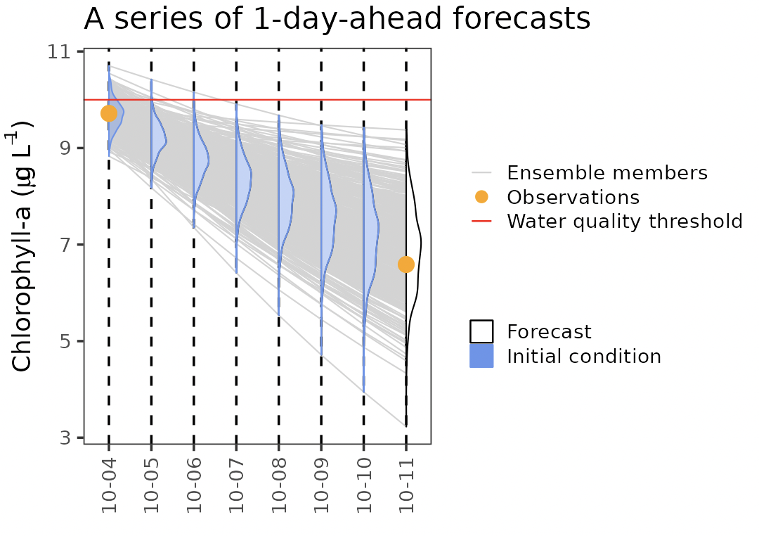
   * *Figure 20. A series of of one-day-ahead forecasts generated using the current forecasting system and data collection method and showing the observation for Saturday, Oct. 11.*
   1. Download the plot of the series of forecasts generated using the borrowed high-frequency sensor AND the observation for Saturday, Oct. 11 and copy-paste it into your report.
   * *Please copy-paste your Q43b-plot.png image here.*
   * 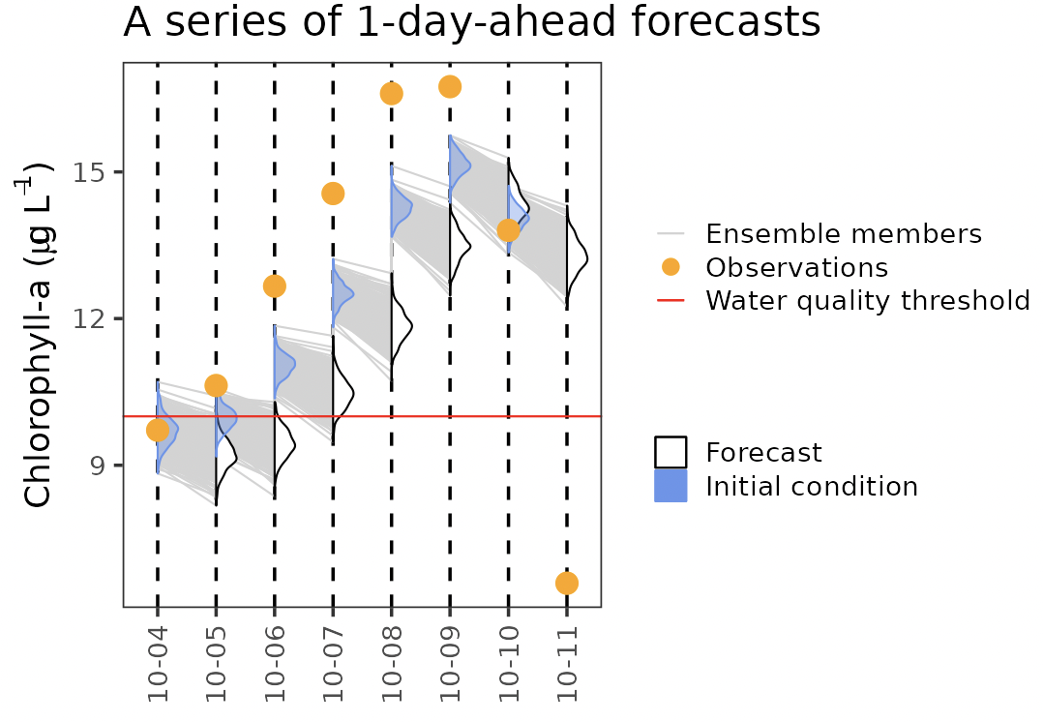
   * *Figure 21. A series of of one-day-ahead forecasts generated using the borrowed high-frequency sensor and showing the observation for Saturday, Oct. 11.*
   1. Which forecast series - the one with or without the high-frequency sensor data - provided a more accurate forecast for Saturday, Oct. 11?
   * **Answer: The forecast without a high-frequency sensor provided a more accurate forecast for October 11. The high-frequency sensor does not include the true observation in he distribution at all.**
   1. How did your lake closure decision made using the forecast series with weekly, manual data assimilation compare to the decision made using the forecast series with daily high-frequency sensor data assimilation?
   * **Answer: I decided not to close the lake with the weekly, manual data assimilation, and I decided to close the lake using the daily high-frequency sensor data assimilation.**
4. Compare the values of bias and RMSE for the forecast series with data assimilation of weekly manual data vs. the forecast series with data assimilation of daily sensor data. Overall, which forecast series produces more accurate forecasts?

* **Answer: The bias is -5.1071 with the weekly manual data and -1.3643 with the daily sensor data. The RMSE is 6.09 with the weekly manual data and 3.92 with the daily sensor data. The daily sensor data has a lower value for both bias and RMSE, indicating that this forecast series produces more accurate forecasts.**

1. Make a final recommendation.
   1. Based on what you have learned from your forecast trials with the high-frequency sensor, do you recommend that the Green Reservoir management authority invest in a new high-frequency sensor to inform their forecasts?
   * **Answer: I would still recommend a high-frequency sensor. While the forecast was incorrect for lake closure on October 11, it was incorrect in the safer way, rather than leaving the lake open when the concentration of chlorophyll-a is too high. The forecasts were also more accurate overall with a lower bias and a lower RMSE.**
   1. Briefly explain the reasoning behind your final recommendation. Did it change from the preliminary recommendation that you made in Q.40?
   * **Answer: Like said before, I recommended this due to more accurate forecasts. This is the same recommendation I made in question 40. It would be different if we had forecasted and decided to keep the lake open when the chlorophyll-a concentration was actually too high, but it is safer to close the lake if we think there will be an issue and have it be safe, than keep the lake open because we think it’s fine but have it be dangerous.**

*This module was initially developed by: Lofton, M.E., T.N. Moore, R.Q. Thomas, and C.C. Carey. 30 January 2024. Macrosystems EDDIE: Using Data to Improve Ecological Forecasts. Macrosystems EDDIE Module 7, Version 1.* [*https://serc.carleton.edu/eddie/teaching_materials/modules/module7.html*](https://serc.carleton.edu/eddie/teaching_materials/modules/module7.html)*. Module development was supported by NSF grants DEB-1926050 and DBI-1933016.* *This app was last updated on: 2024-02-06*